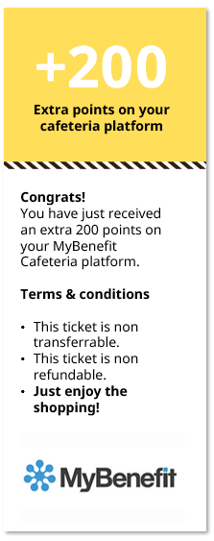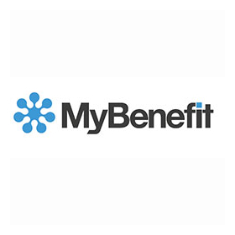

As Ingvar said *„(…) No one can be happy or do a good job unless they like the place where they work. After all, it’s there that they spend most of their waking hours.* ***Feeling appreciated and motivated leads to good results.”***

We'd like to thank you for the first months of your IKEA Journey. We value your engagement in People Operation Transformation project and attention to the details, openness to learn new processes and supportive attitude towards your colleagues and team leaders. It's a real pleasure to work with you! Keep up the good job!

**YOU’RE THE BEST!**

This is the big thank you to:

**Agata Bajsztok**

**Katarzyna Koźlicka**

PA/PY Deputy Team Leader

**Agata Bajsztok**

PA/PY Team Leader

**Agnieszka Choodowska**

PA/PY Team Leader

**María Belén Toro Mallero**

PA/PY Services Manager

**Congrats!**

You have just received an extra 200 points on your MyBenefit Cafeteria platform.

**Terms & conditions**

* This ticket is non transferrable.
* This ticket is non refundable.
* **Just enjoy the shopping!**

**+200**

**Extra points on your cafeteria platform**

SSC Poznan